documentation of acceptance test cases and evidence of test execution (when they were run; pass/fail status of each run)

Expectations of this test:

1. Catch bugs
2. Increases confidence in application
3. Speeds up QA time
4. Can serve as documentations

Type of tests :

Unit tests(jest ):

Screen.test in react library:

|  |  |  |  |  |  |  |
| --- | --- | --- | --- | --- | --- | --- |
|  | getBy | findBy | QueryBy | getAllBy | findAllBy | queryAllBy |
| No match | Error | Error | Null | Error | Error | Array |
| Match | Return | Return | Return | Array | Array | Array |
| Match+1 | Error | Error | Error | Array | Array | Array |
| Await | No | Yes | No | No | Yes | no |

Introduction :

Checking whether the code meets certain expectations or not is the fundamental part of Testing. And there are 3 type of testing way. And the specific Type we using to test our project is Unit(test)which is also called React Jest.

The following is what typical test process looks like:

1. import the function to be tested
2. Input to the function
3. Check the expectation
4. Compare the input and expectation

I’ve created some test file for each function that I have achieved on the front-end of react and paste it below: all test file are in the folder called :Testfiles

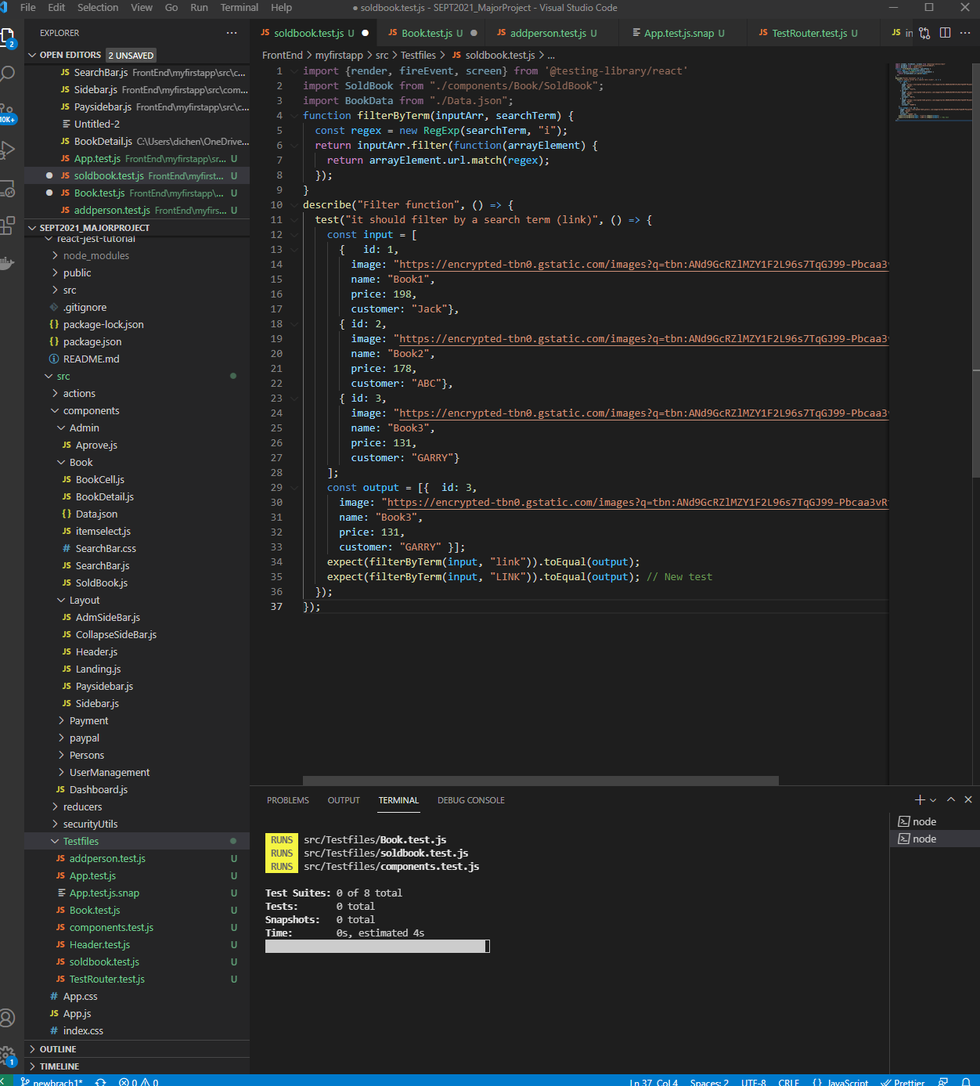

For the test OF SoldBook, The first step is to define an simple input just like the api that came from database and define an expect result and give “link” as search when run the test file it can tell about the test result.

The test of app.js is passed. And there are 1 test in total. But the rest of the test file was failed with the fail of test suites.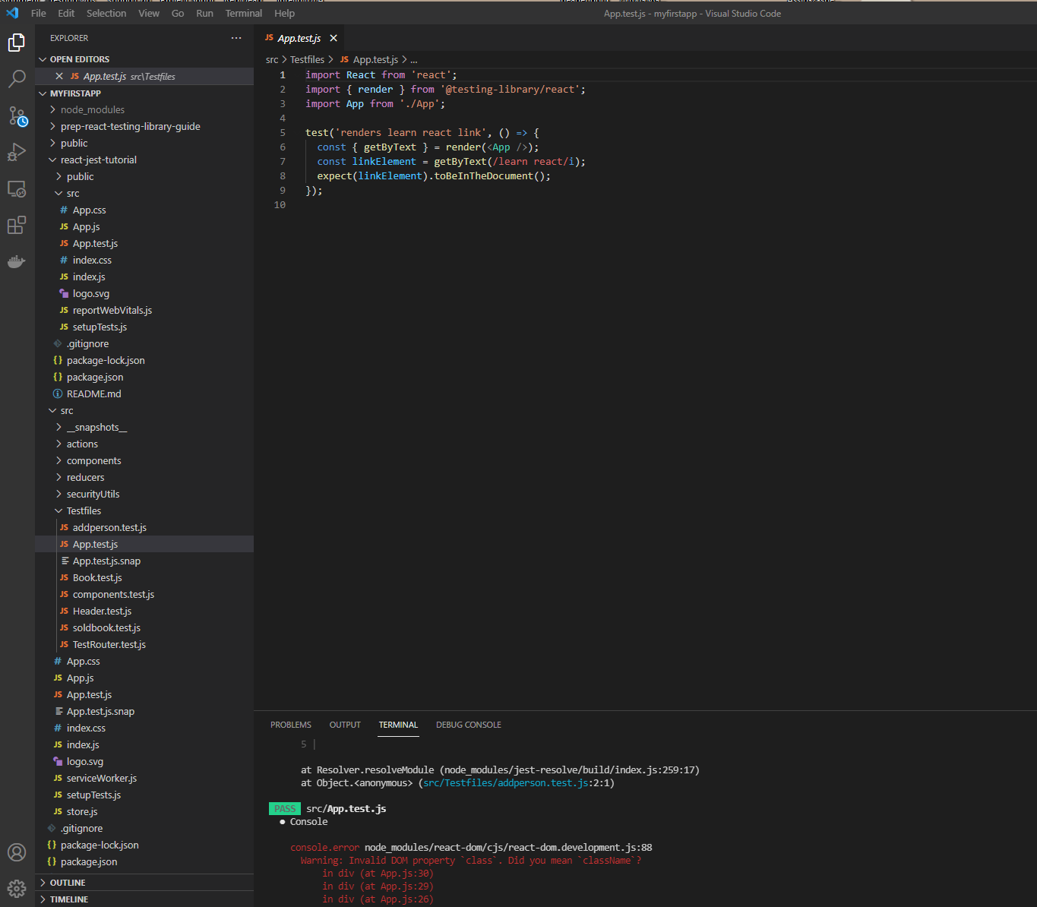

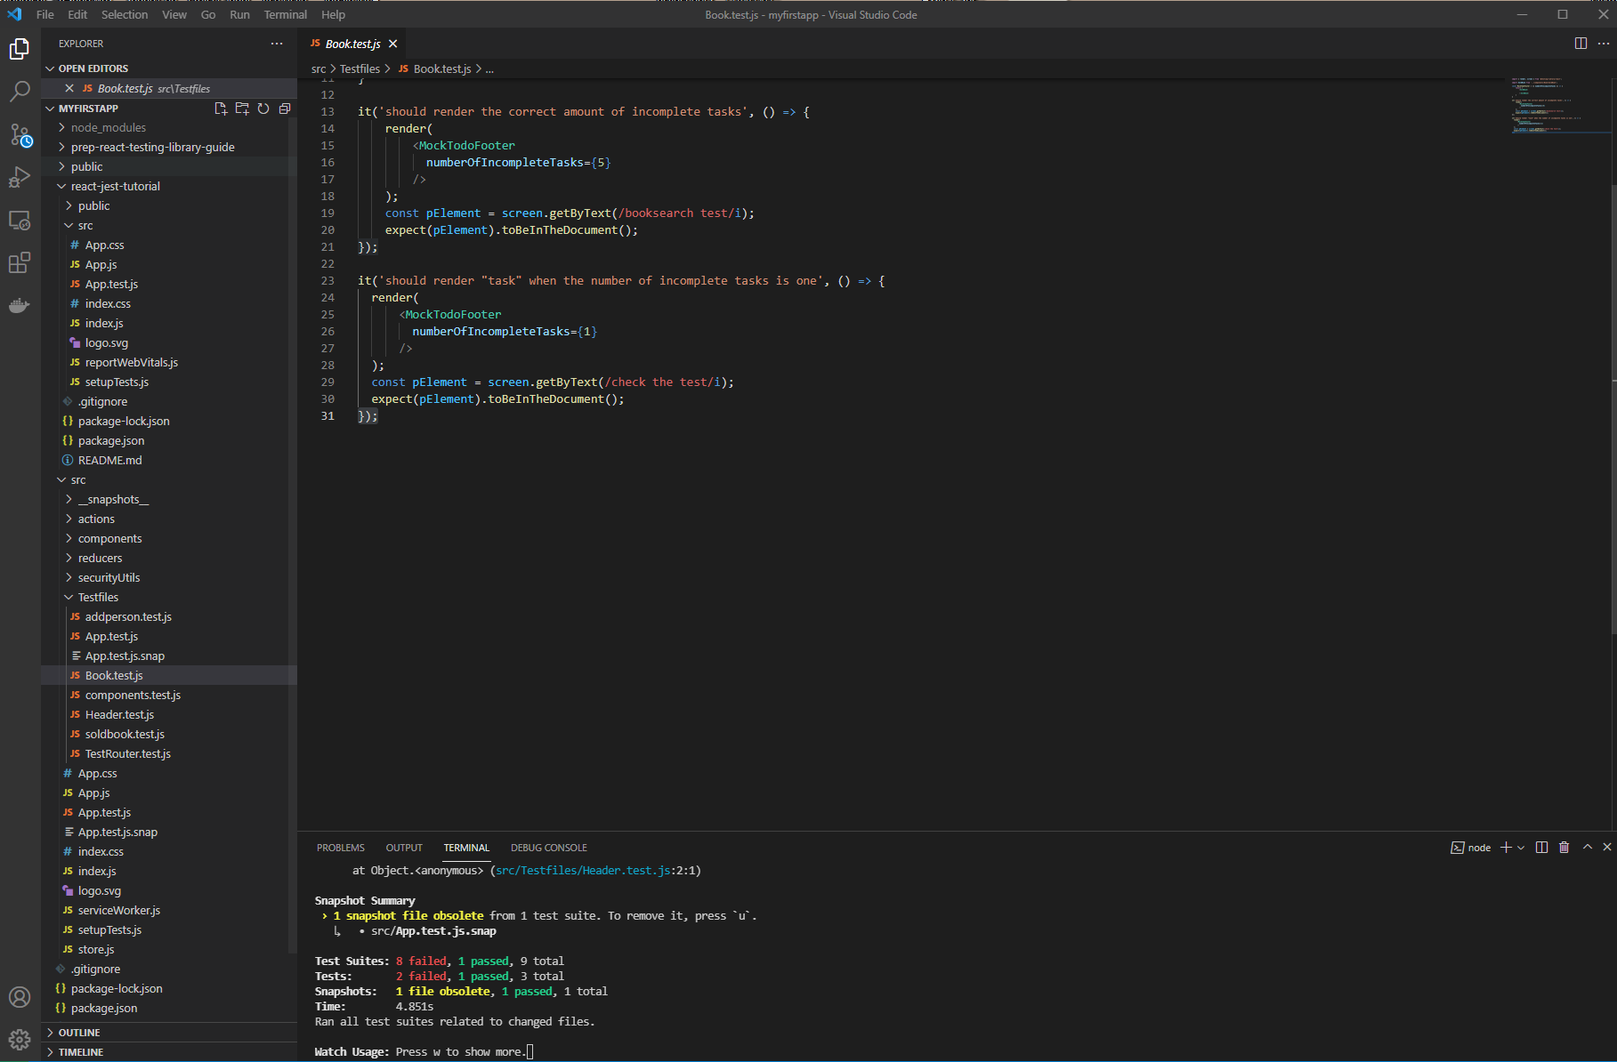

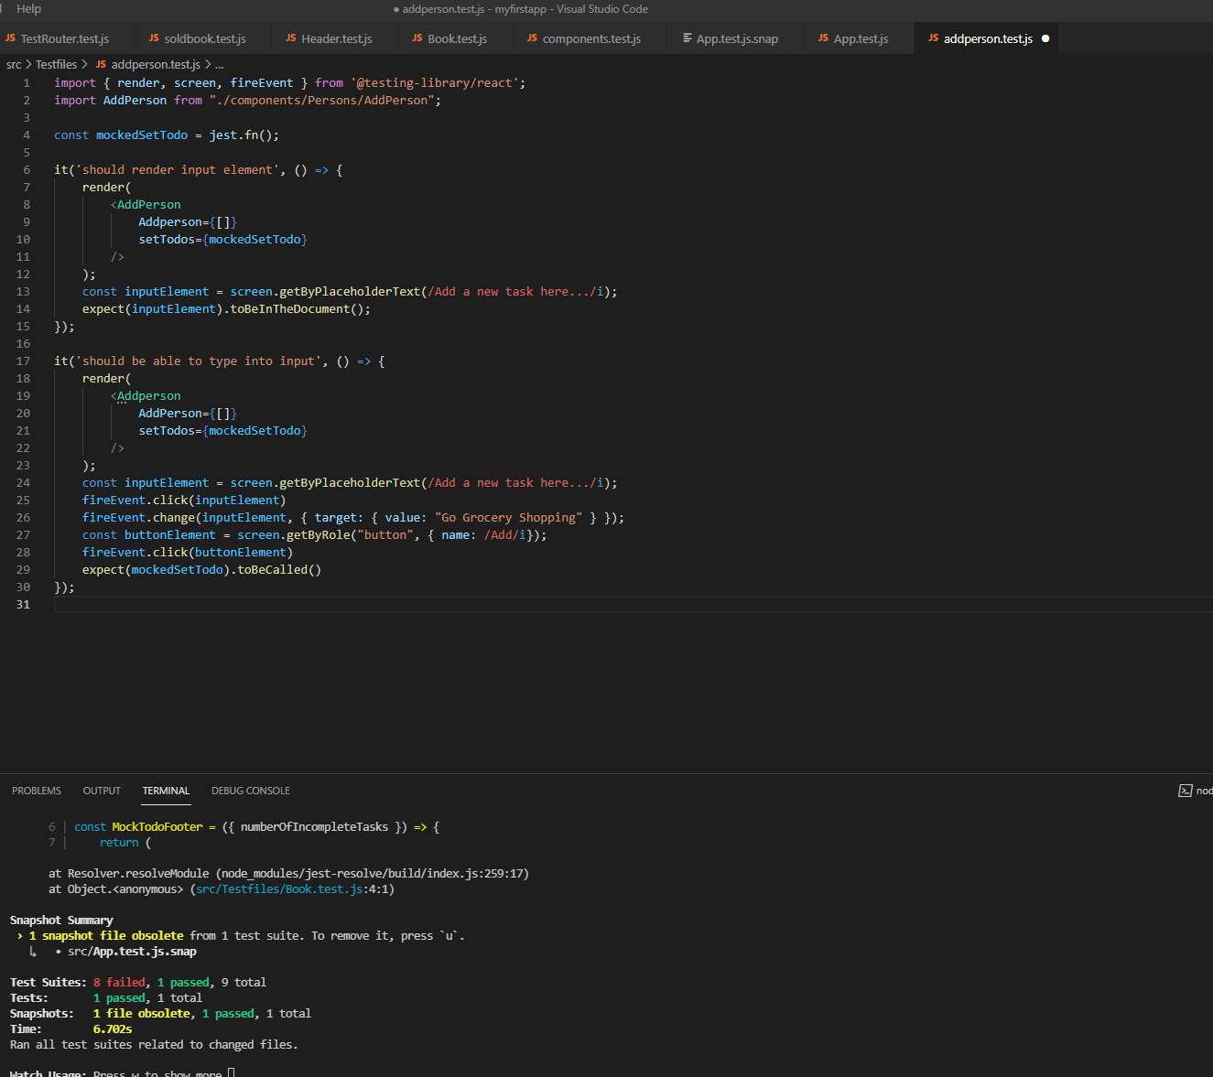

Testrouter file is use to test the side bar and those martial_ UI that I’ve use on the web

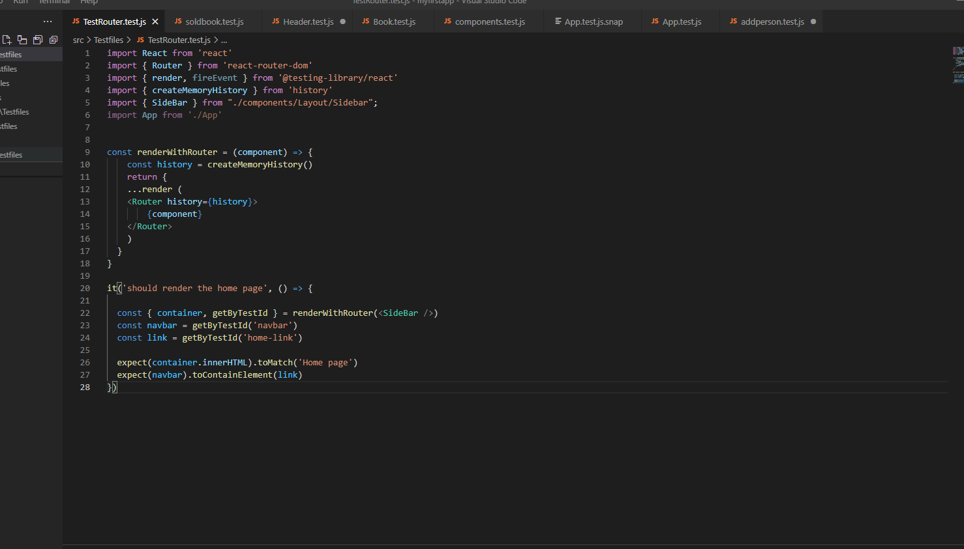

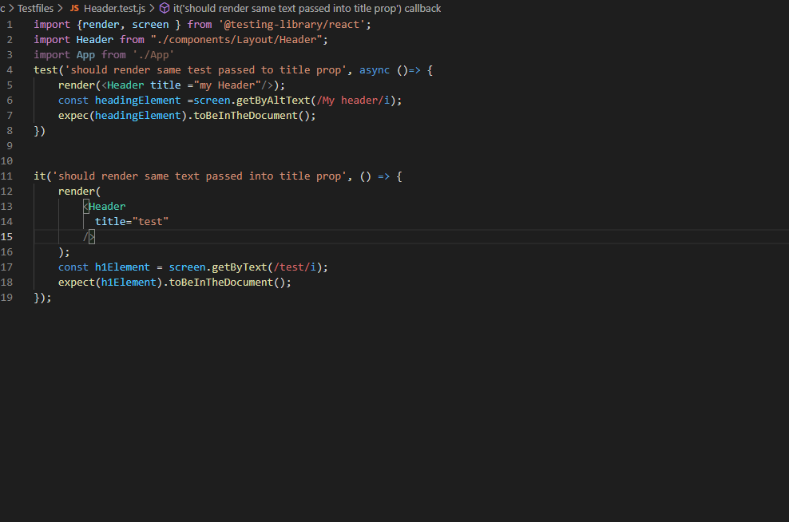

Snapshot below:

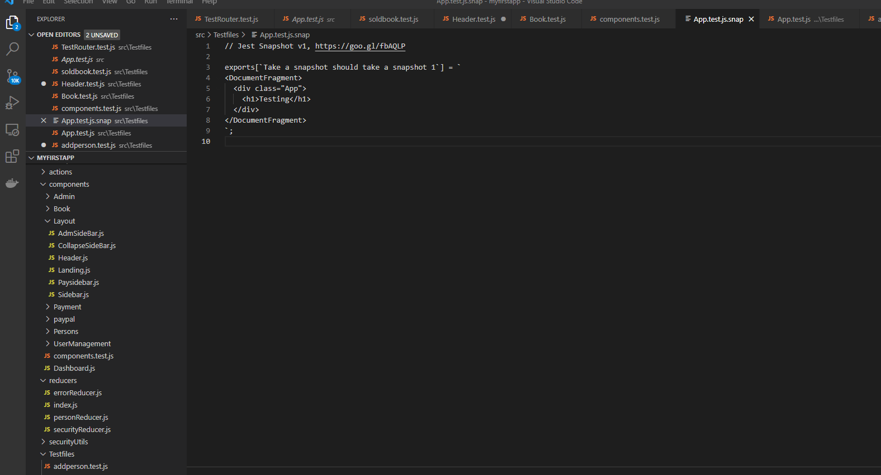

Conclusion:

Unit testing can provide a basic guarantee for the development and maintenance, so we can complete the construction and reconstruction of the code. As the test result, only the app.test.js successfully passed, the rest of the function of the website based on front-end is operation normally, but the test of it is still failed. Based on the result of the circleci, the test of front end is running as we except.

